**CSA1518 – CLOUD COMPUTING & BIG DATA ANALYTICS FOR SOCIAL MEDIA**

**G SHIYAM SUNDHAR**

**(191911582L)**

**EXP – 09**

***Create a snapshot of a VM and test it by loading the previous version/cloned VM.***

***Step 01:***

Create a VM ware at first stage.

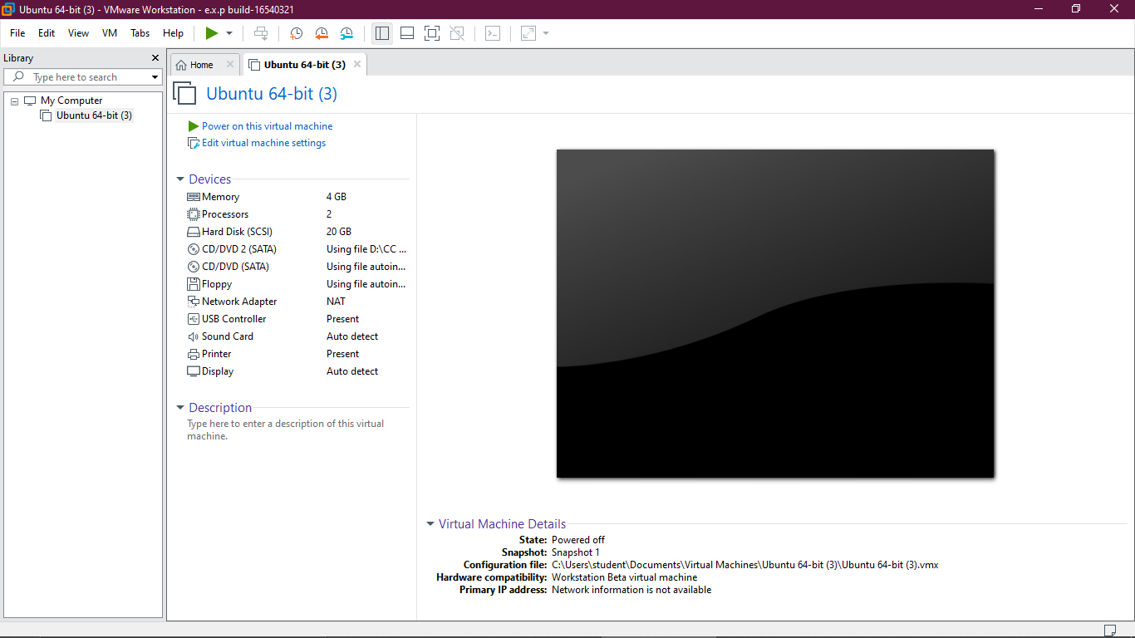

***Step 02:***

Then select VM Task bar and select the option snapshot and click “Take snapshot”.

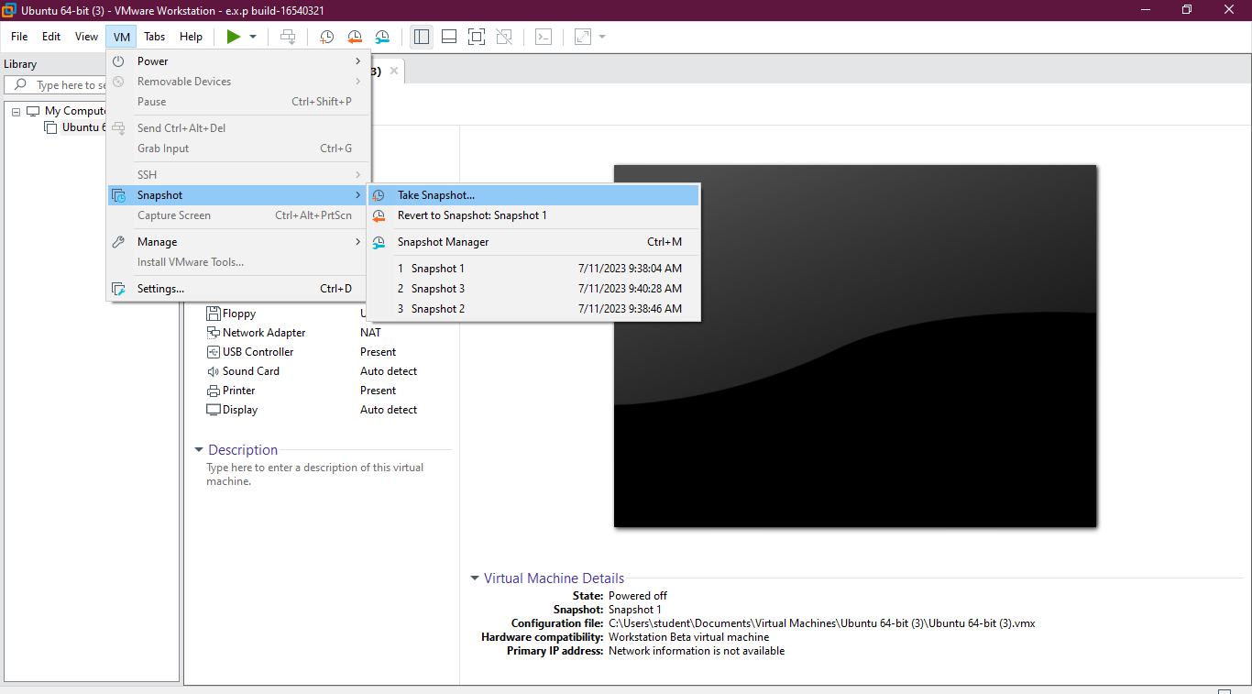

***Step 03:***

Enter the time in DESCRIPTION BOX and click “Take snapshot”. This process will be repeated for required snapshots Once the Specification have been changed single time then the snapshots need to be taken.

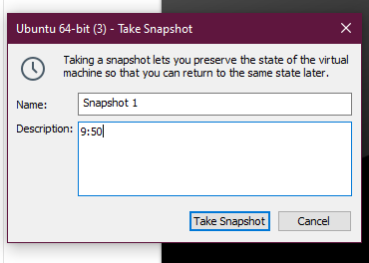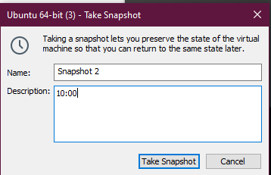

***Step 04:***

Click the VM option in task bar then click snapshot and click snapshot manager and select the snapshot which we needed to revert back and the click “Goto”.

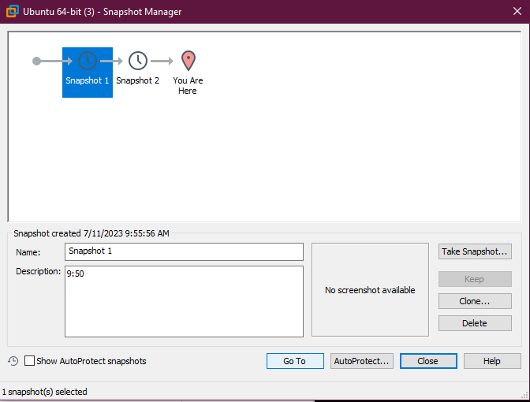

***Step 05:***

Click the goto option and the snapshot which we selected will displayed again.

